URL: https://adityabirlahospital.com/blogs/types-of-diabetes
Meta Title: Types of Diabetes: Type 1, Type 2, & Gestational | Aditya Birla Memorial Hospital
Meta Description: Explore Type 1, Type 2, and gestational diabetes, their causes, symptoms, diagnosis, and complications, plus key differences between each type.
Types of Diabetes: Differences Between Type 1, Type 2, and Gestational Diabetes
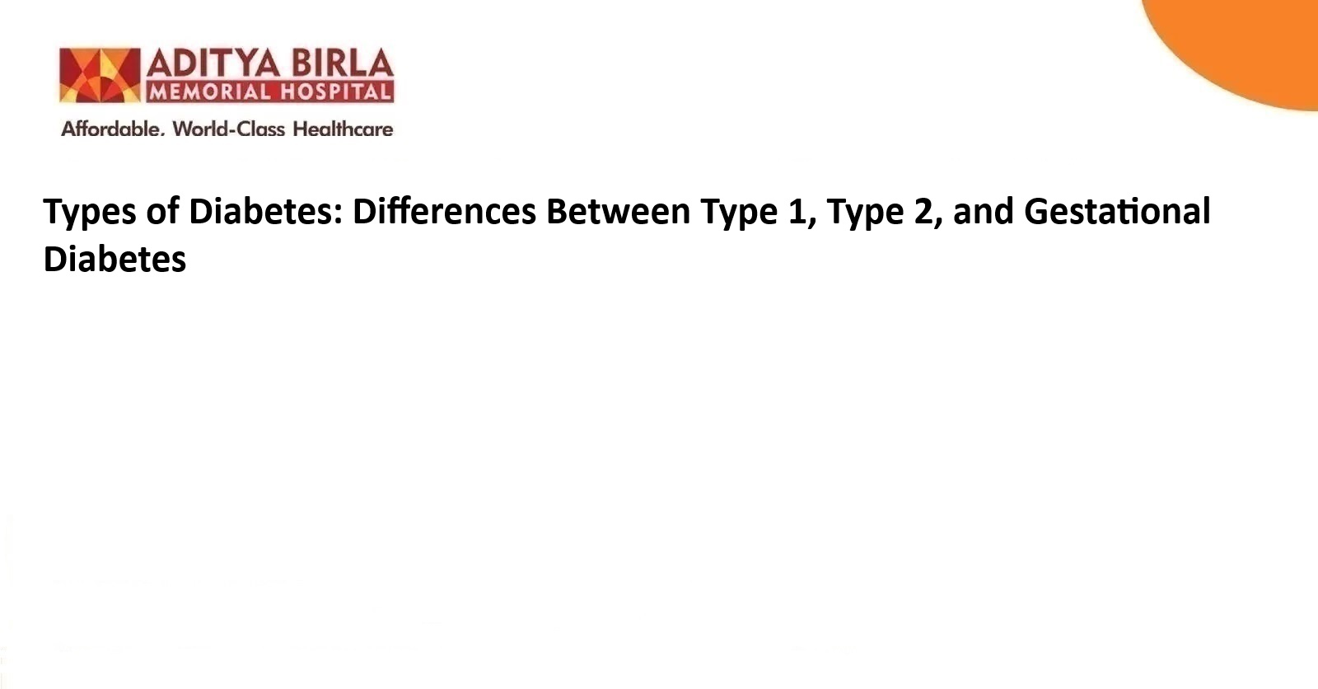
Diabetes is an amalgamation of multiple chronic conditions that affect how the body processes glucose. Each type presents unique clinical patterns and long-term consequences. Some individuals are diagnosed early due to specific immune-related triggers. On the other hand, others may develop symptoms later because of lifestyle changes or pregnancy-induced hormonal shifts.
Although these types share common features such as elevated blood glucose, the underlying causes differ. Proper identification of diabetes types is critical for long-term monitoring and treatment. The risks of future complications also vary between these conditions. Gaining a comprehensive understanding of the different types of diabetes enables more accurate prediction of disease progression and supports structured care planning.

What is Diabetes?
Diabetes is a metabolic disorder marked by elevated blood glucose levels. The condition develops when the pancreas produces insufficient insulin or when the body becomes insulin-resistant. This leads to poor blood sugar regulation, which may affect several organs over time. Diabetes types differ by cause and progression.
Despite these variations, all forms may lead to serious complications if not managed appropriately. High glucose levels may damage blood vessels, nerves, kidneys, and eyes. Identifying the exact type allows physicians to choose targeted interventions. Each type of diabetes also has a distinct timeline of risk.
What are the Main Diabetes Types?
There are three primary types of diabetes. These include type 1 diabetes, type 2 diabetes, and gestational diabetes.
1. Type 1 diabetes is often autoimmune in nature. It typically presents in childhood or adolescence and requires lifelong insulin therapy.
2. Type 2 diabetes develops gradually and is directly linked to insulin resistance. It is often observed in adults and is influenced by metabolic risk factors.
3. Gestational diabetes arises during pregnancy (primarily due to hormonal changes).
Although usually temporary, it may raise the future risk of developing permanent diabetes. Each type requires a different approach to diagnosis, management, and follow-up, and the best diabetes hospital in Pimpri-Chinchwad, Pune, can help you manage your diabetes.
Type 1 Diabetes
The destruction of pancreatic beta cells characterises type 1 diabetes. The process is conventionally autoimmune, leading to a complete lack of insulin production. It frequently begins in childhood or adolescence, and in some cases, the onset occurs in adulthood with a more gradual presentation.

Common symptoms include:
· Increased thirst
· Frequent urination
· Unexplained weight loss
· Fatigue
These symptoms may appear suddenly and progress rapidly. The precise cause of type 1 diabetes is not fully understood. Genetic predisposition and environmental factors may both contribute to the problem. Management requires insulin therapy from the time of diagnosis. Lifestyle changes alone are not sufficient.

Type 2 Diabetes
The presence of insulin resistance and progressive beta-cell dysfunction defines type 2 diabetes. Insulin is still produced but is not used effectively by the body (unlike type 1 diabetes). However, over time, insulin production gradually decreases. Type 2 diabetes tend to develop gradually, often without noticeable symptoms in the early stages.

Individuals may remain undiagnosed for years! Additionally, the risk factors include obesity, physical inactivity, advancing age, and family history. In many cases, changes in weight and metabolism contribute to the onset of disease. Early diagnosis is important because the condition may lead to complications involving the heart, kidneys, and eyes.

Gestational Diabetes
Gestational diabetes is a condition in which glucose intolerance is first identified during pregnancy. Hormonal changes impair insulin sensitivity, resulting in elevated blood glucose levels. It generally develops during the second or third trimester. Although the condition usually resolves after delivery, it may indicate underlying metabolic vulnerability.

A long-term study showed that over half of the women with gestational diabetes later developed type 2 diabetes. Certain cases also progressed to type 1 diabetes within the first decade. These findings highlight the importance of sustained follow-up after pregnancy. Early monitoring may help identify risks and support preventive strategies.

Other Types of Diabetes
Beyond the main categories, there are several less common types of diabetes.
1. Monogenic diabetes arises from single-gene mutations and may occur at a young age.
2. Neonatal diabetes is diagnosed within the first six months of life and has distinct genetic causes.
3. Secondary diabetes may develop due to pancreatic disease, hormonal disorders, or certain medications.
These types of diabetes are rare but clinically significant. Accurate classification is essential to avoid mismanagement. In many cases, genetic testing or specialised laboratory work is required. Although uncommon, these conditions may present diagnostic challenges and require specific treatment approaches.
How Do Doctors Diagnose Diabetes Type?
Diabetes diagnosis is based on blood glucose testing. A fasting plasma glucose test or an oral glucose tolerance test is typically used. Long-term glucose levels may be assessed using HbA1c testing. Identifying the type of diabetes involves additional assessments.

These may include age at diagnosis, symptom pattern, insulin requirement, and family history. For gestational diabetes, diagnosis is usually made during pregnancy using glucose tolerance tests. In the long-term cohort study, the presence of high fasting glucose and the need for insulin during pregnancy predicted both type 1 and type 2 diabetes in the following decades.
Complications of Diabetes
Diabetes may lead to complications affecting multiple organs. These include nephropathy, retinopathy, neuropathy, and cardiovascular conditions. The risk increases with poor glycaemic control and delayed diagnosis.
The duration of the disease may also influence the likelihood of complications. In type 1 diabetes, early insulin therapy may help reduce the risk. In type 2 diabetes, undetected hyperglycaemia may cause cumulative organ damage.
Women with gestational diabetes face an elevated risk of developing type 2 diabetes later. This also increases the chance of complications if not identified early. Long-term monitoring is essential even after pregnancy-related glucose levels return to normal.
Conclusion
Diabetes is not a single disease but a group of conditions with distinct causes and outcomes. Type 1 diabetes is autoimmune and begins early. Type 2 diabetes is linked to insulin resistance and develops over time. Gestational diabetes occurs during pregnancy but may signal long-term metabolic risk.
For more information on diabetes, its types, and how to manage it, book an appointment with the best diabetologist in Pune.
Frequently Asked Questions (FAQs)
1. Can diet and exercise control diabetes?
In type 2 diabetes, lifestyle modifications such as diet and physical activity may improve insulin sensitivity and help manage glucose levels. These measures may delay or reduce the need for medication.

2. Who is more likely to develop Type 2 diabetes?
Individuals with obesity, limited physical activity, a family history of diabetes, or previous gestational diabetes may be at greater risk of developing type 2 diabetes over time.

3. What is gestational diabetes, and does it go away after pregnancy?
Gestational diabetes develops during pregnancy due to hormonal effects on insulin action. It usually resolves after delivery, but may increase the risk of future type 2 diabetes.

4. What is the difference between Type 1 diabetes and Type 2 diabetes?
Type 1 diabetes results from autoimmune loss of insulin production and appears early. Type 2 diabetes develops gradually and involves resistance to insulin rather than absolute deficiency.

5. What causes diabetes in general?
Diabetes causes differ by type. Type 1 diabetes is autoimmune. Type 2 diabetes arises from insulin resistance and metabolic factors. Gestational diabetes is triggered by pregnancy-related hormonal changes.

